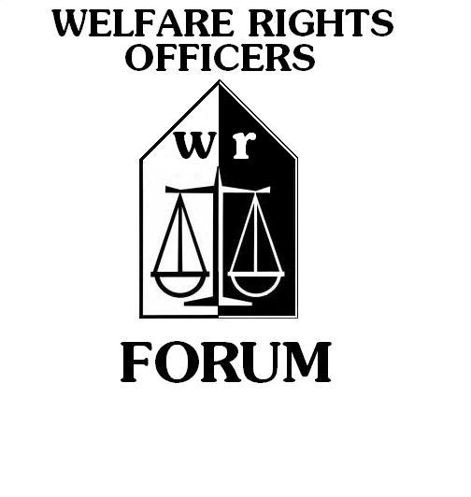
Minutes of AdvicePro Group Meeting
6th October 2022
Online teams Meeting

Item 1: Attendance and Apologies

In Attendance:

Sean Doak, Dunedin Canmore HA
Morag Bisset, Hillhead HA
Lisa McCaig, Cassiltoun HA
Douglas McAndrew, WSHA
Laura Reilly, Wellhouse HA
Isabel Brodie, NVHA
Ruth Matheson, Parkhead HA
Lucy Adesegun, Wheatley Homes Glasgow
Jacqueline Russell, North Ayrshire Council
Kim Grimley, North Ayrshire Council
Kirsty Brown, North Ayrshire Council
Paula Beaton, AdviceUK

Minutes - Morag Bisset

Item 1: Welcome
Morag welcomed everyone to the meeting .

Item 2: AdvicePro Demonstration

Paula reminded everyone that the Document Portal is currently free for all users until March 2023. If you have not already activated the portal, email her and she can get it turned on for your organisation.

Paula then ran through the various modules on AdvicePro:
- Group Actions
- Advanced Search
- Document Portal- through email and text
- Docusign facility- which needs the TextAnywhere module to send a signature link to clients to allow them to remotely sign documents such as mandates etc.
- Customisation- such as adding priority groups, health needs etc
- The export to Outlook for appointments & tasks, which allows the recording of cancellations/no-shows etc for reports
- Scored Outcomes- for recording soft outcomes, rather than CFG
- Social Policy Issues- to record trends in your local area, such as loan sharks, Cost of Living Crisis etc

User guides on all of these modules can be found in the Help & Support Section of AdvicePro which can be access via the ‘?’ in the top tight-hand corner, where you log-out!

Paula will re-issue the Energy Customisation factsheet, which Morag will email round the forum.

Additionally, several members raised issues with the Portal, and she will look into this with the AdviceUK team, and get back to us.

